SIGNOZ – STANDALONE INSTALLATION
STEP-1: Get and extract the latest release of SigNoz
curl -L https://github.com/SigNoz/signoz/releases/latest/download/signoz_linux_$(uname -m | sed 's/x86_64/amd64/g' | sed 's/aarch64/arm64/g').tar.gz -o signoz.tar.gz
tar -xzf signoz.tar.gz
STEP-2: Create the necessary directories and copy the extracted files to
sudo mkdir -p /opt/signoz
sudo mkdir -p /var/lib/signoz
sudo cp -r signoz_linux_$(uname -m | sed 's/x86_64/amd64/g' | sed 's/aarch64/arm64/g')/* /opt/signoz
STEP-3: Create the SigNoz systemd environment file
sudo bash -c 'cat <<EOF > /opt/signoz/conf/systemd.env
SIGNOZ_INSTRUMENTATION_LOGS_LEVEL=info
INVITE_EMAIL_TEMPLATE=/opt/signoz/templates/invitation_email_template.html
SIGNOZ_SQLSTORE_SQLITE_PATH=/var/lib/signoz/signoz.db
SIGNOZ_WEB_ENABLED=true
SIGNOZ_WEB_DIRECTORY=/opt/signoz/web
SIGNOZ_JWT_SECRET=secret
SIGNOZ_ALERTMANAGER_PROVIDER=signoz
SIGNOZ_TELEMETRYSTORE_PROVIDER=clickhouse
SIGNOZ_TELEMETRYSTORE_CLICKHOUSE_DSN=tcp://localhost:9000?password=password
DOT_METRICS_ENABLED=true
EOF'
NOTE:
Here, modify as
SIGNOZ_TELEMETRYSTORE_CLICKHOUSE_DSN=tcp://172.31.19.40:9000?username=default&password=pranavpp37%40
Explanation: Clickhouse vm private ip : 172.31.19.40 and password: pranavpp37@
Here ‘@’ is encoded as %40.
STEP-4: Create a user and group to run SigNoz and give it ownership of the signoz directories
sudo getent passwd signoz >/dev/null || sudo useradd --system --home /opt/signoz --no-create-home --user-group --shell /sbin/nologin signoz
sudo chown -R signoz:signoz /var/lib/signoz
sudo chown -R signoz:signoz /opt/signoz
STEP-5: Create the SigNoz systemd service
sudo bash -c 'cat <<EOF > /etc/systemd/system/signoz.service
[Unit]
Description=SigNoz
Documentation=https://signoz.io/docs
After=clickhouse-server.service

[Service]
User=signoz
Group=signoz
Type=simple
KillMode=mixed
Restart=on-failure
WorkingDirectory=/opt/signoz
EnvironmentFile=/opt/signoz/conf/systemd.env
ExecStart=/opt/signoz/bin/signoz server

[Install]
WantedBy=multi-user.target
EOF'

STEP-6: Reload the systemd daemon and start the SigNoz service
sudo systemctl daemon-reload
sudo systemctl start signoz.service
STEP-7: Verify the installation
sudo systemctl status signoz.service
sudo journalctl -u signoz.service -f
STEP-8: Add inbound rules in Security Group
Go to AWS → VM2 → Security Group → Inbound Rules
Add:
Type | Port | Source
Custom TCP | 8080 | Your IP

As of now, It is configured as 0.0.0.0/0 [This is not recommended in production].

STEP-9: Verify in browser
http://<SigNoz_VM_Public_IP>:8080

Password: Pranavpp37@12345
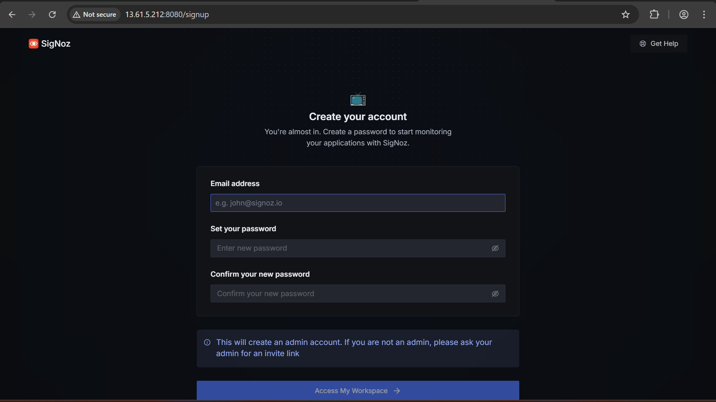

STEP-10: Verify in Clickhouse VM
clickhouse-client --host 172.31.19.40 --port 9000 --user default --password
SHOW DATABASES;
